C950 Task-2 WGUPS Write-Up

(Task-2: The implementation phase of the WGUPS Routing Program)

Sochandaling Teng

ID # 010309126

WGU Email: steng5@wgu.edu

Date: 11/22/2023

C950 Data Structures and Algorithms II

# A. Hash Table

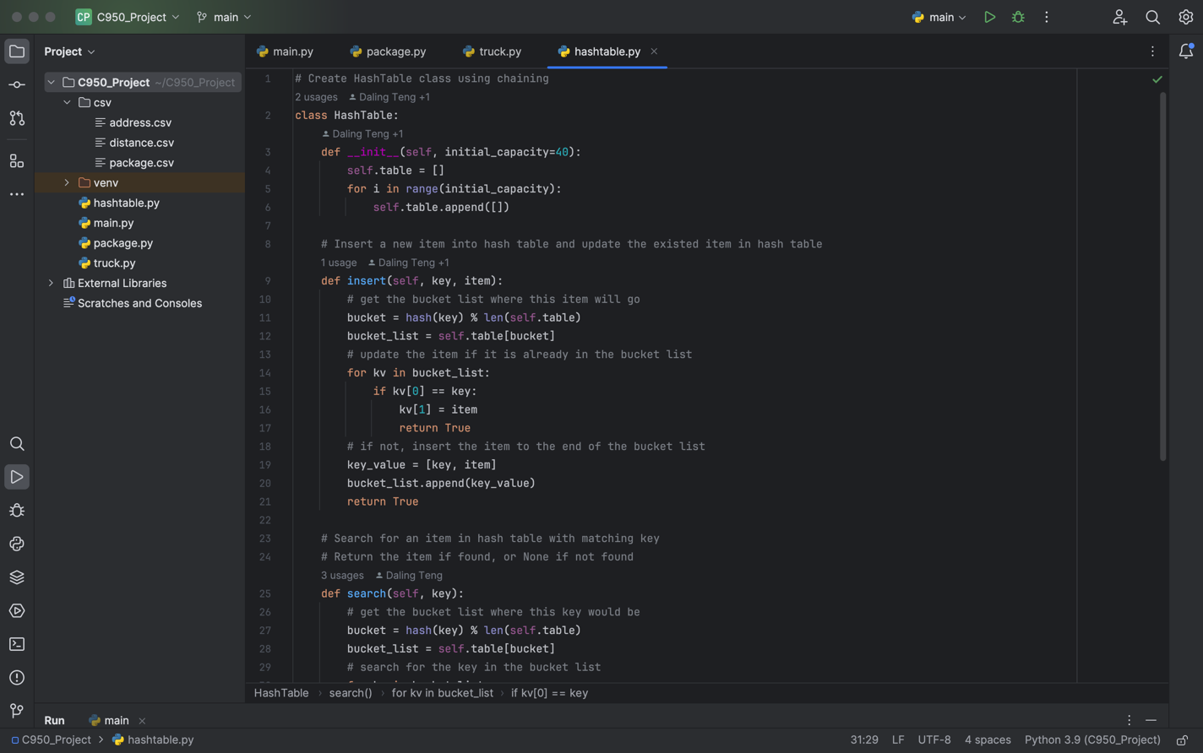

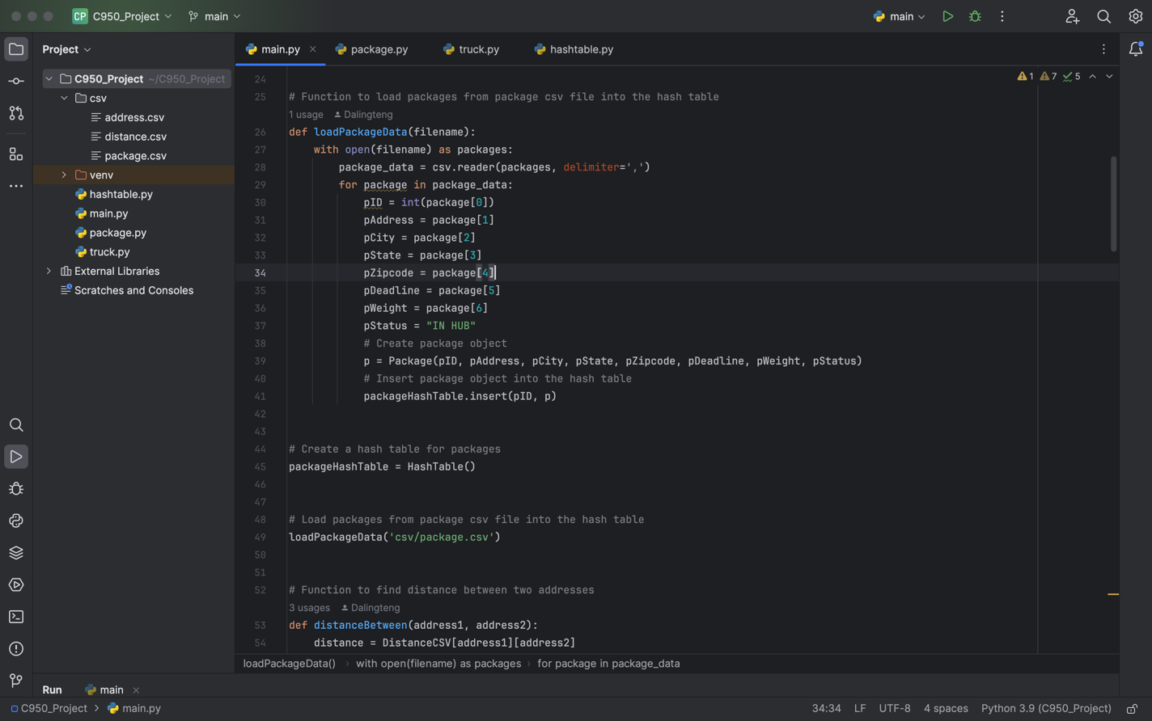

# B. Look-Up Functions

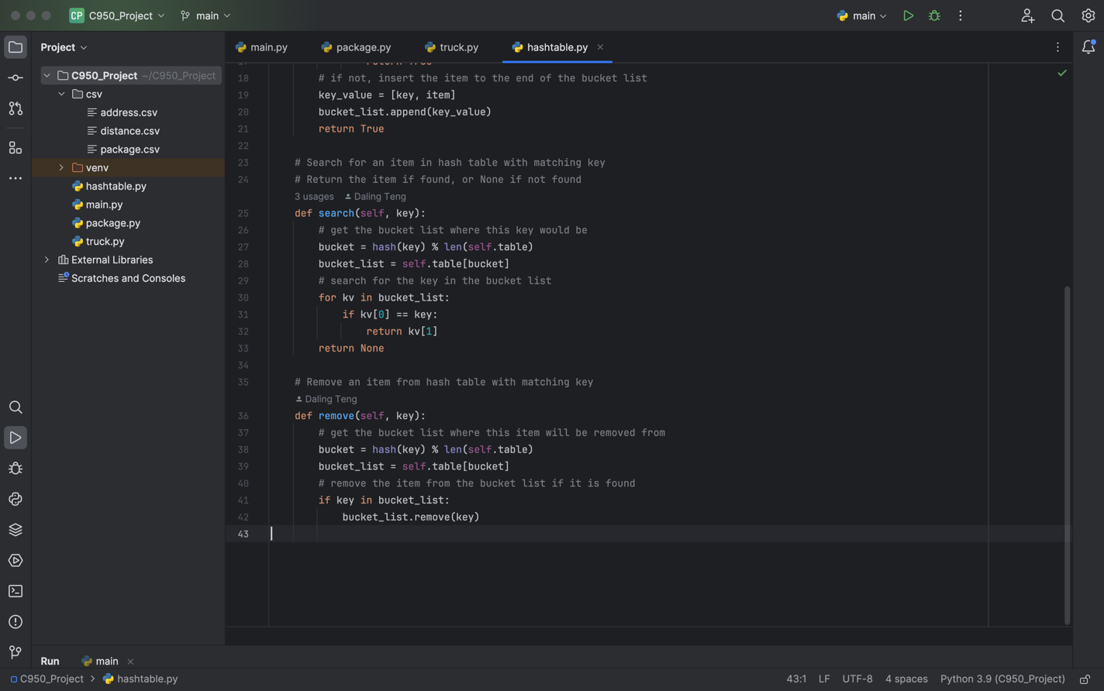

# C. Original Code

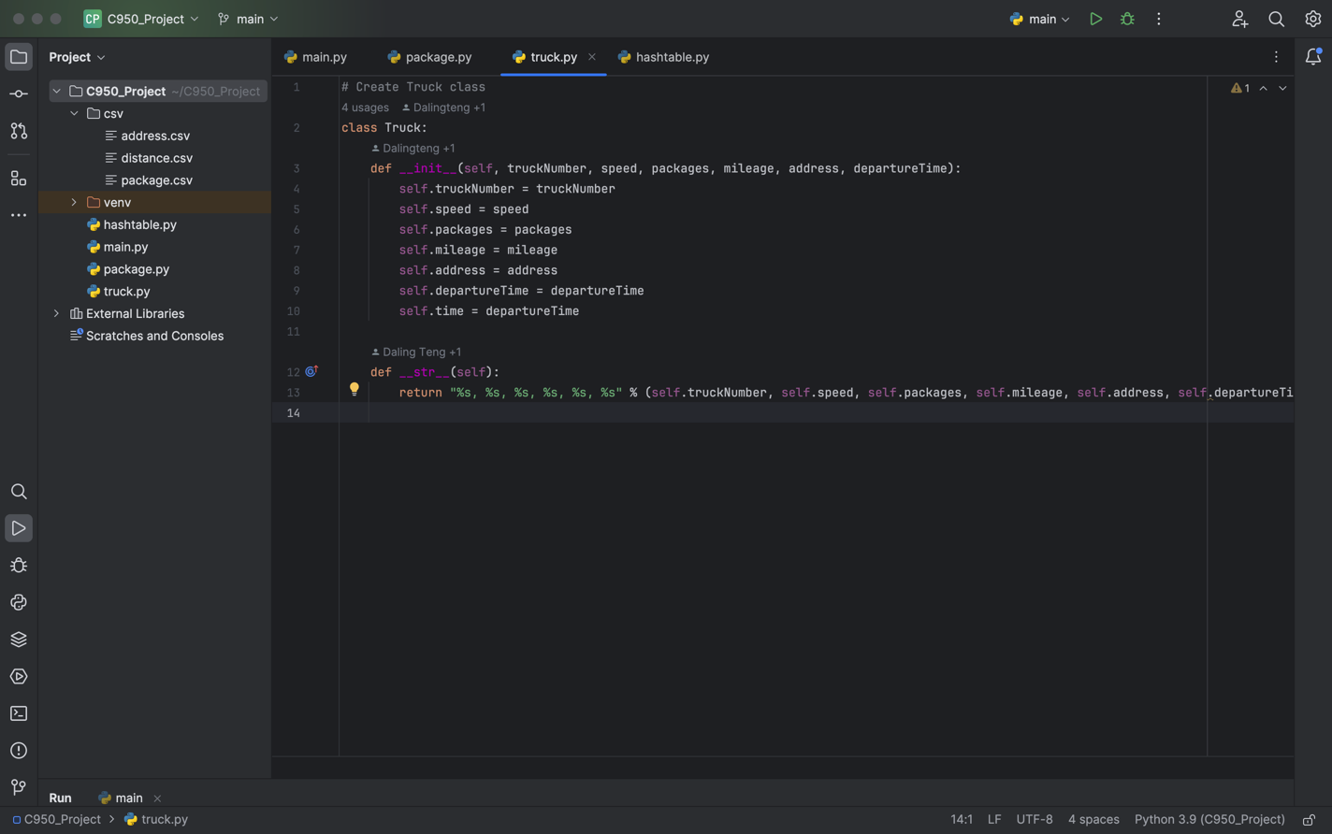

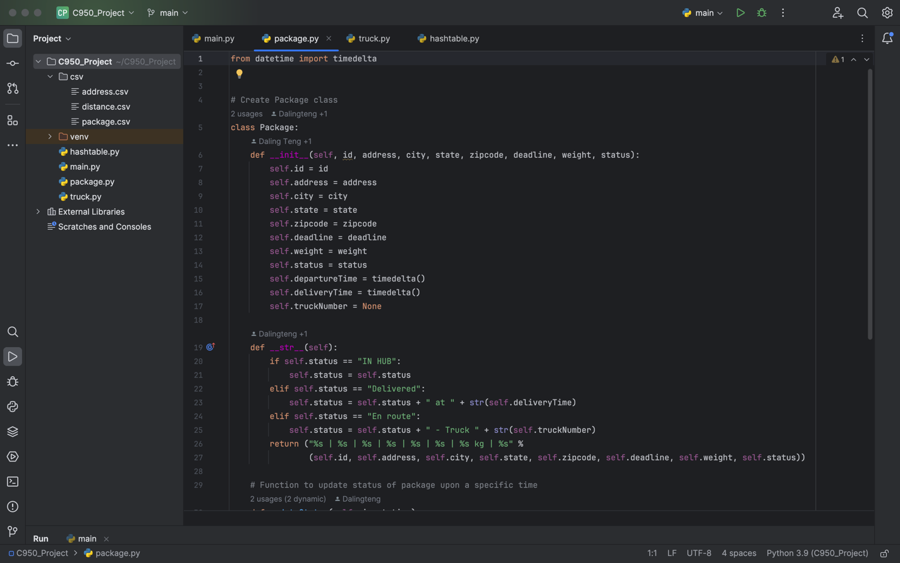

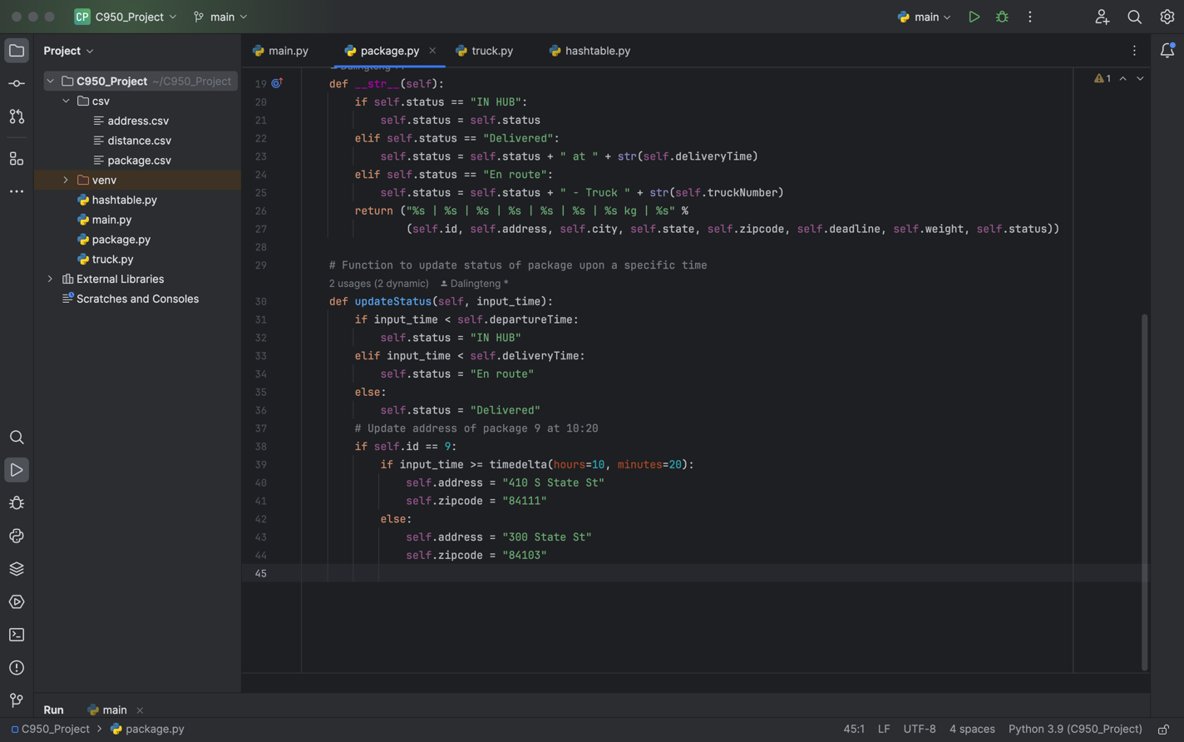

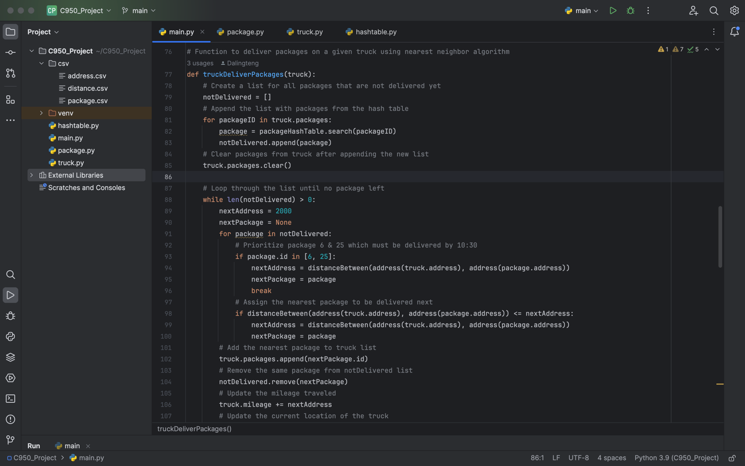

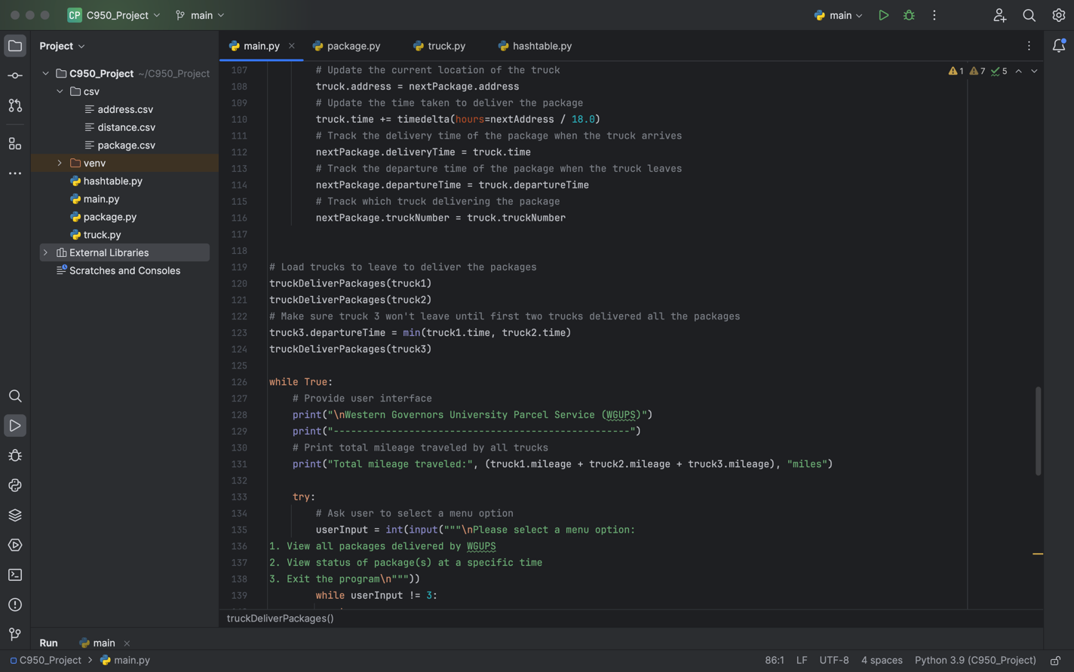

# C1. Identification Information

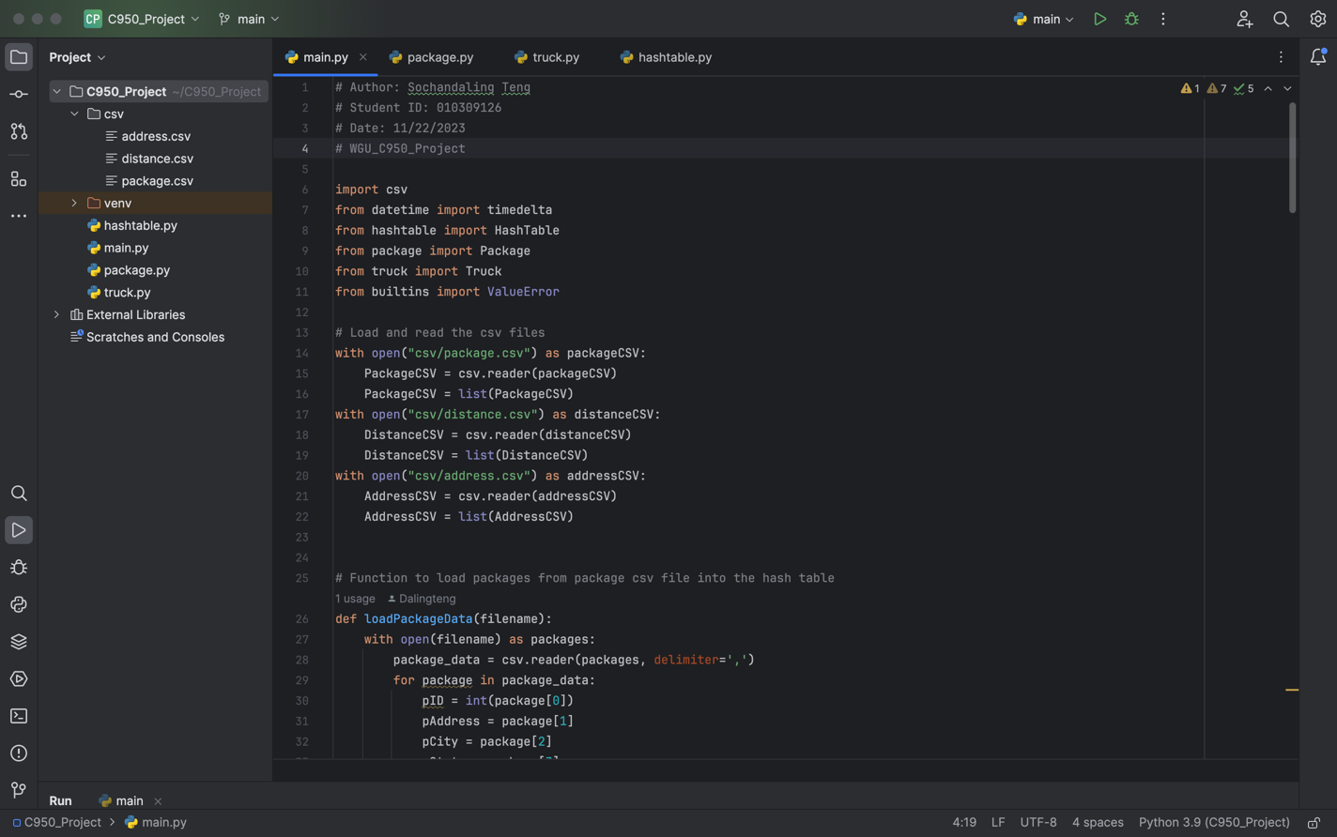

# C2. Process and Flow Comments

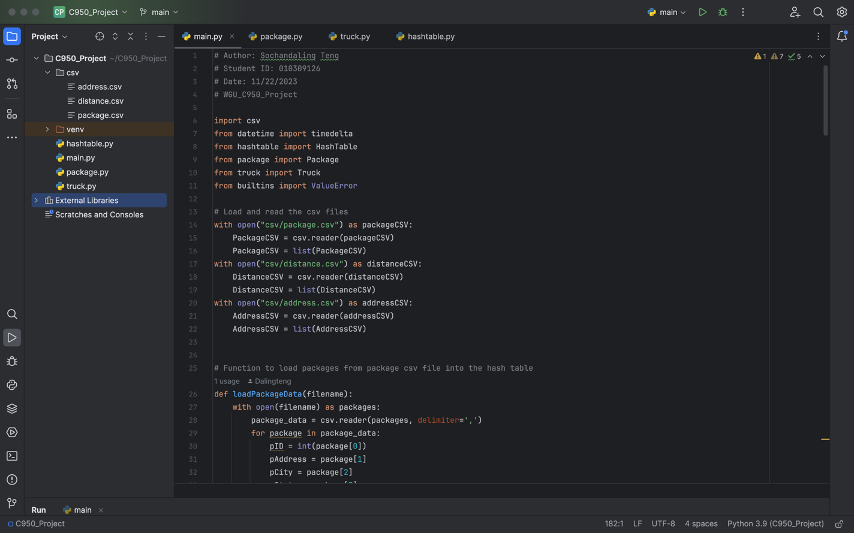

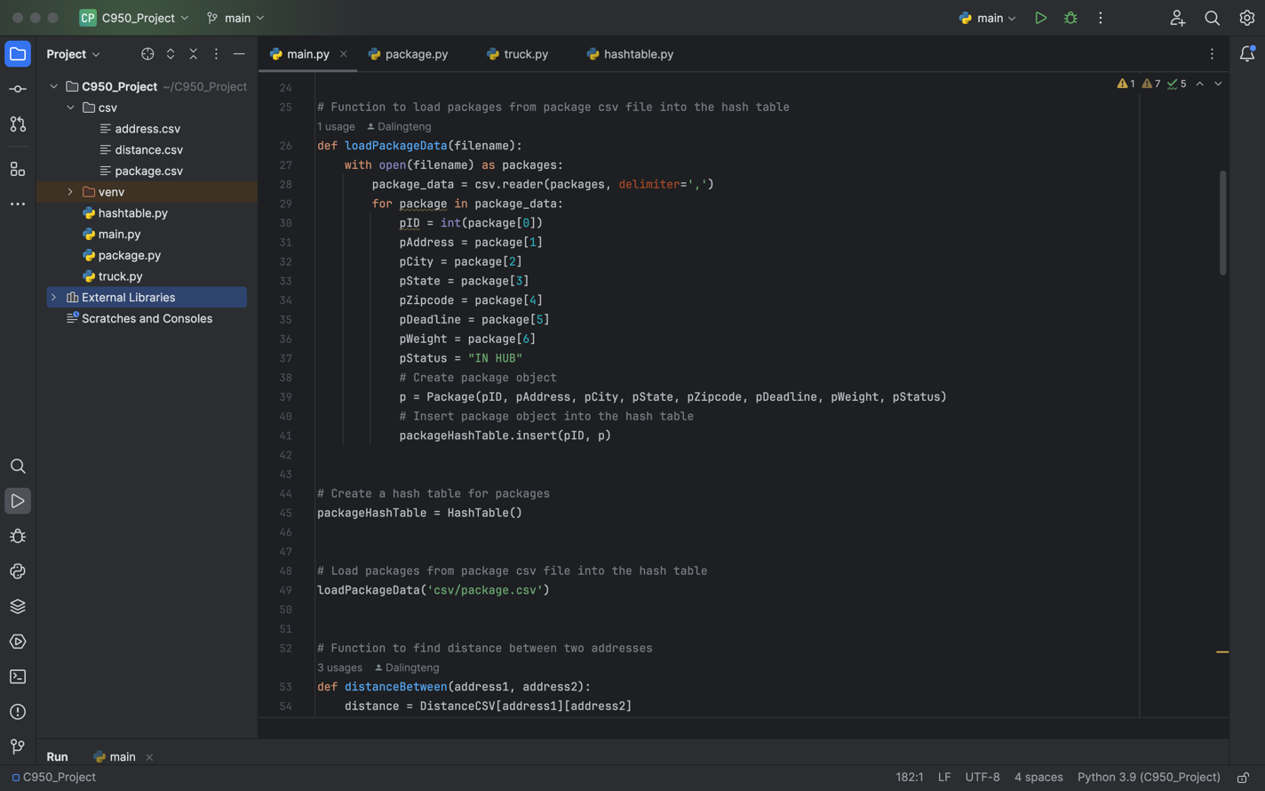

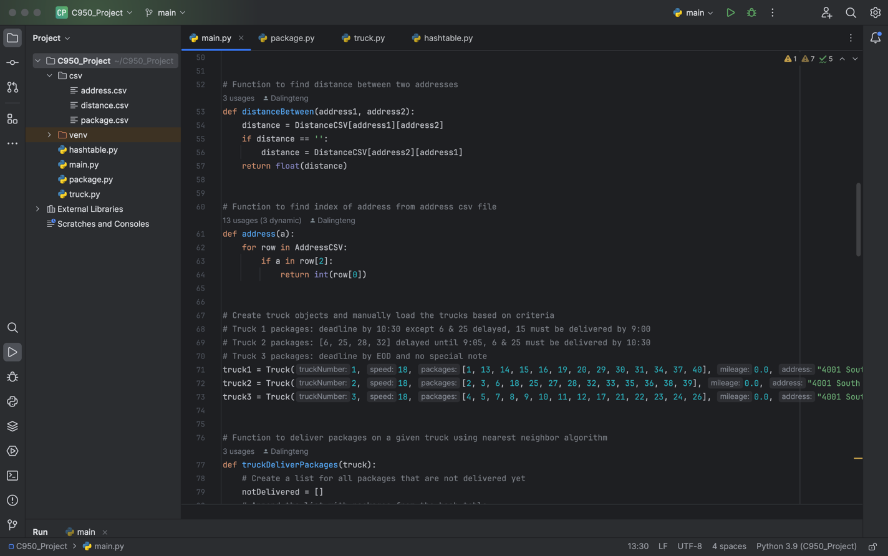

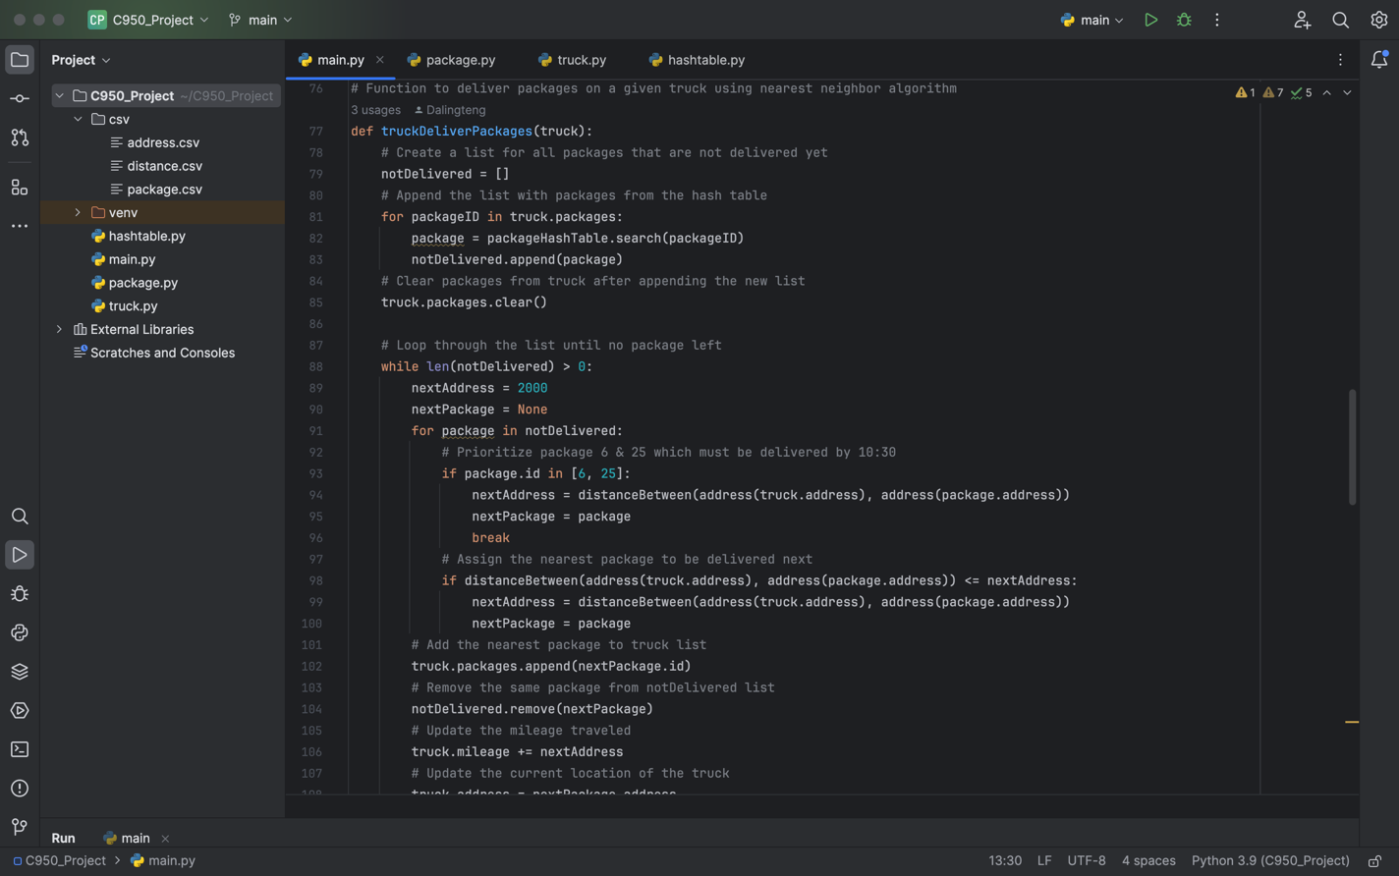

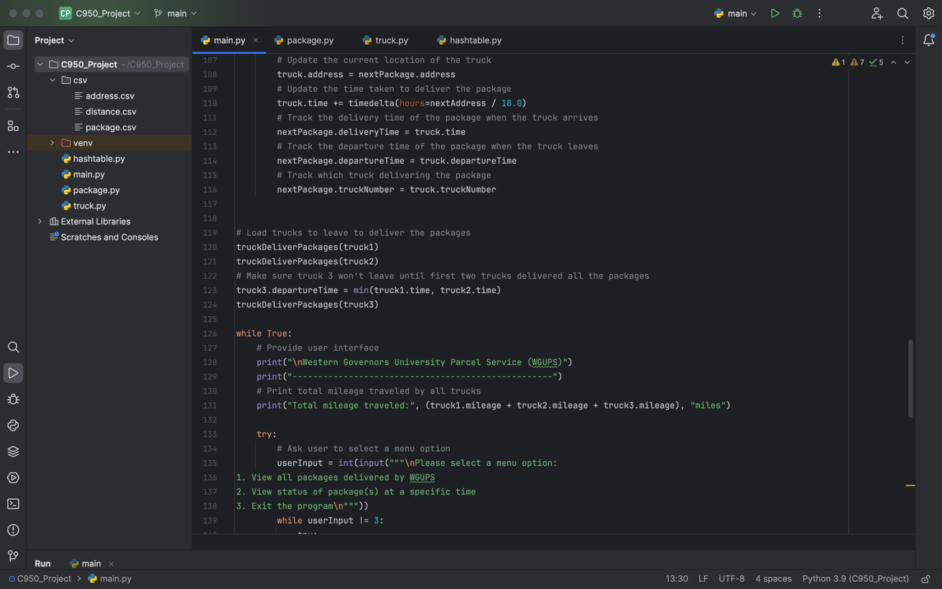

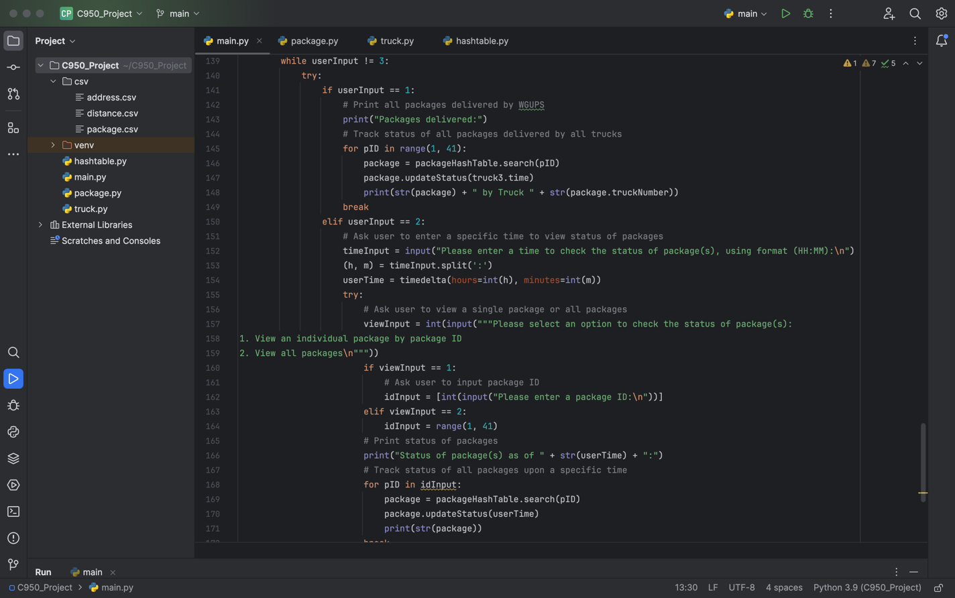

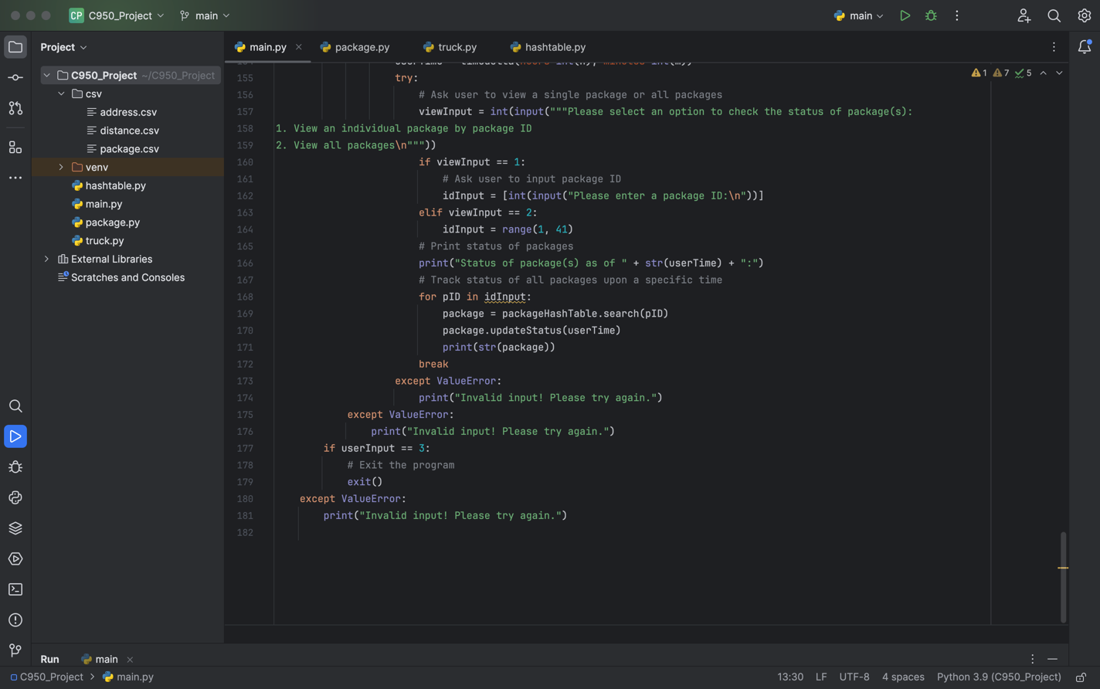

# D. Interface

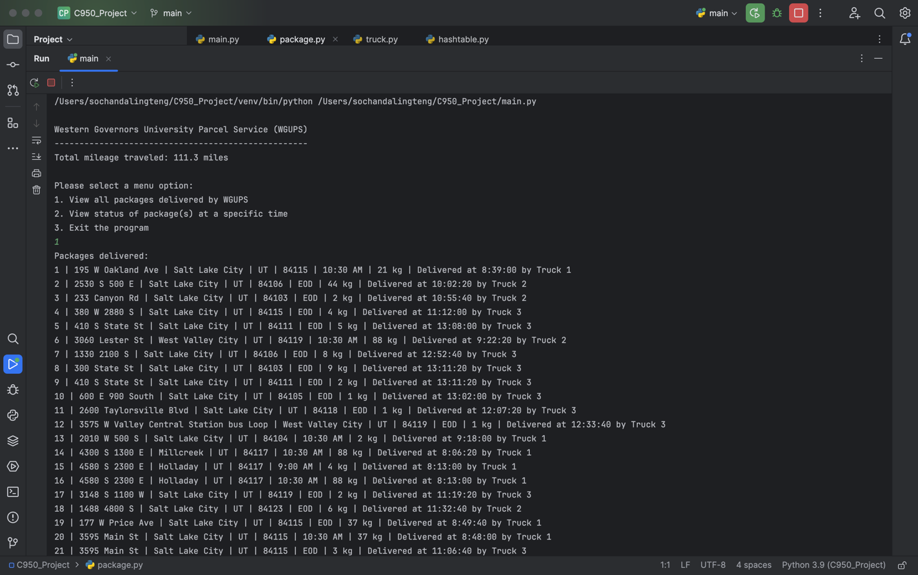

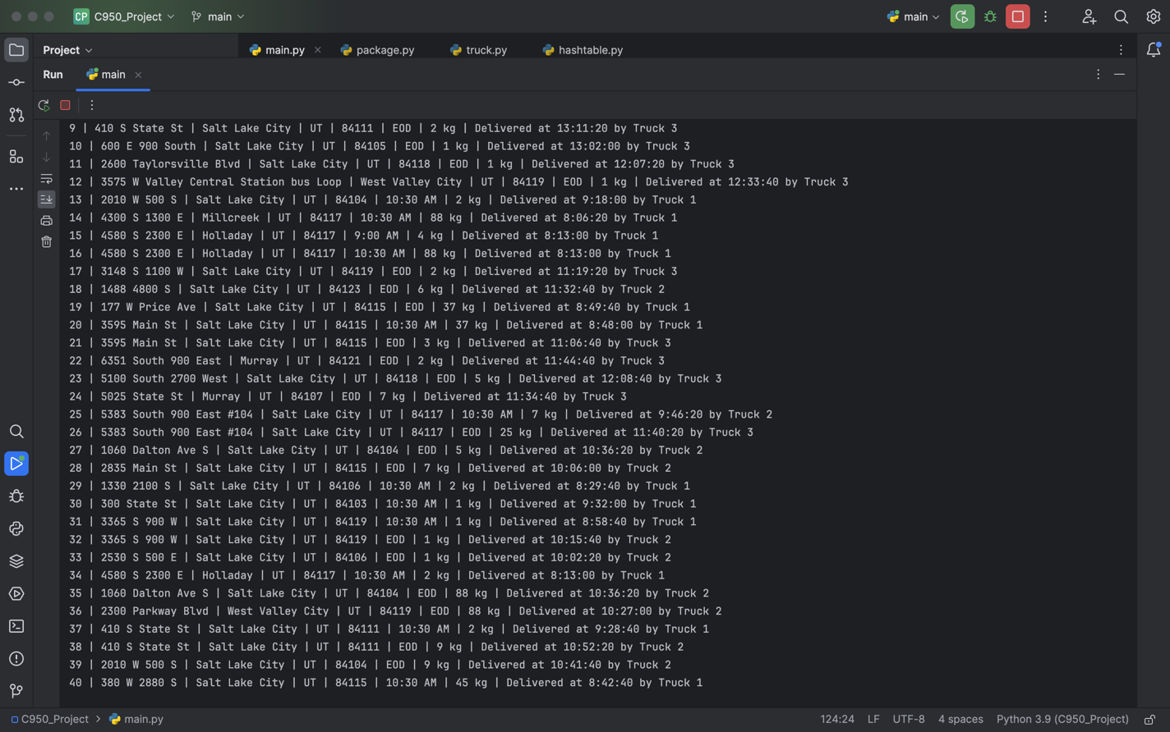

# D1. First Status Check

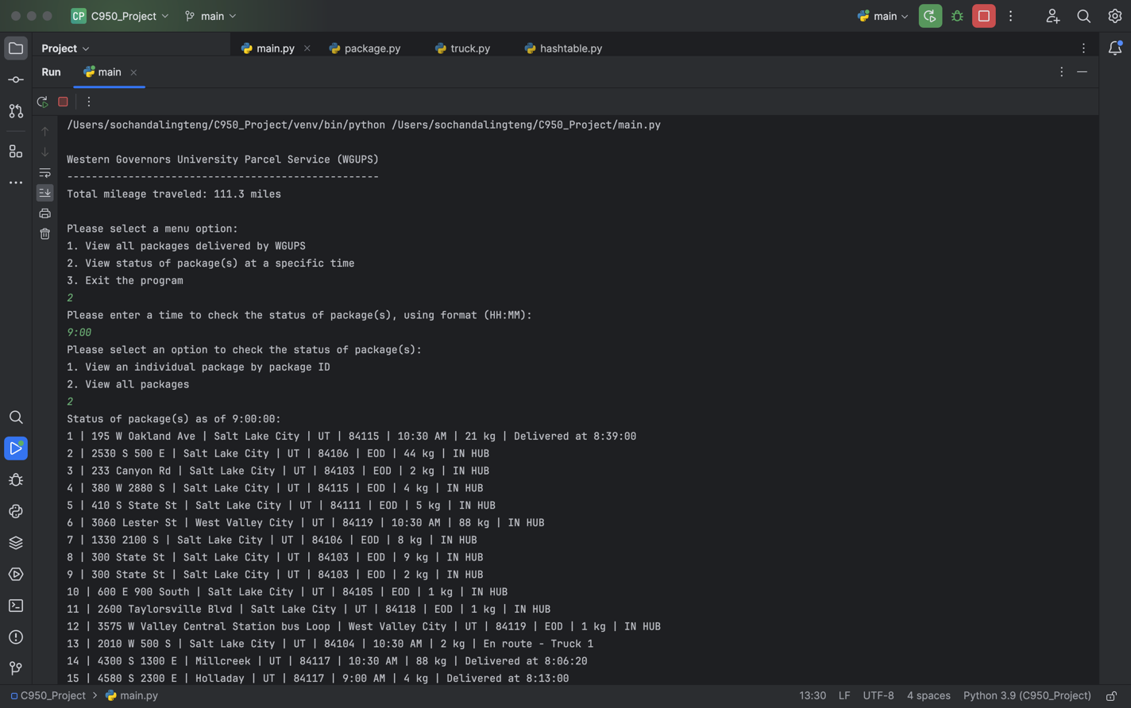

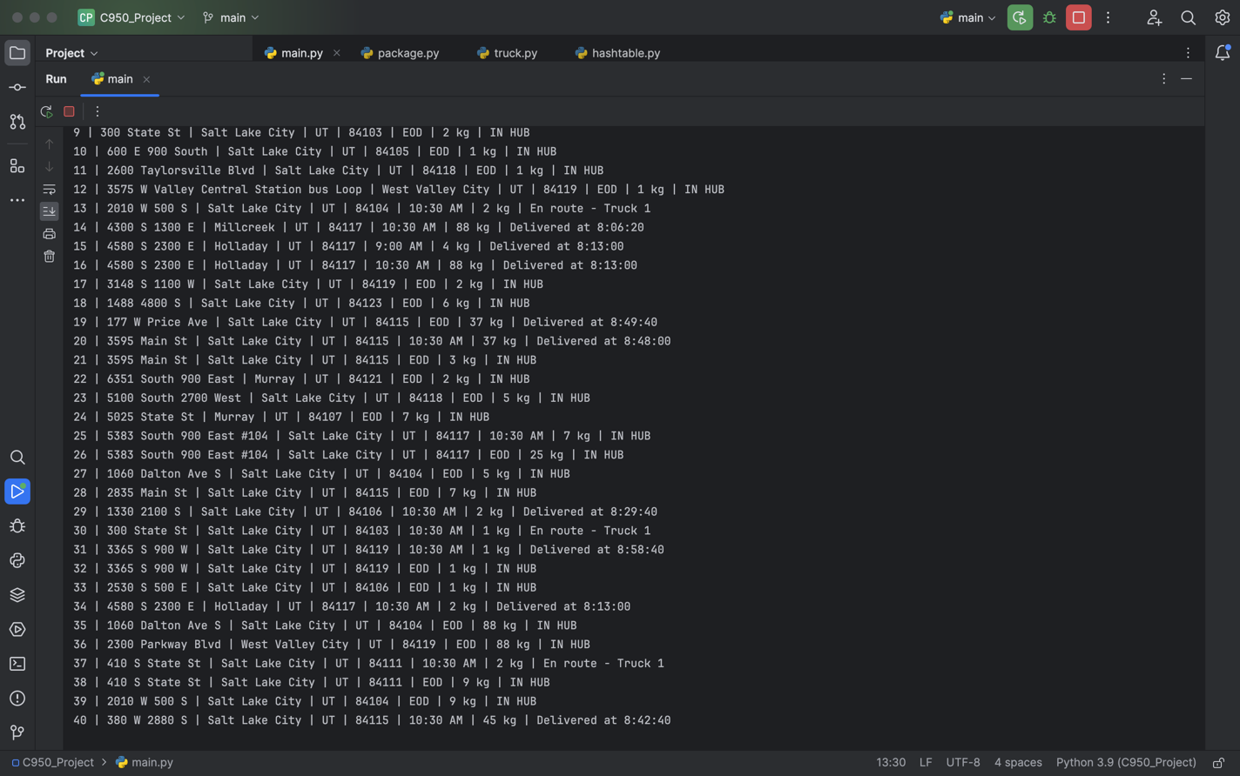

# D2. Second Status Check

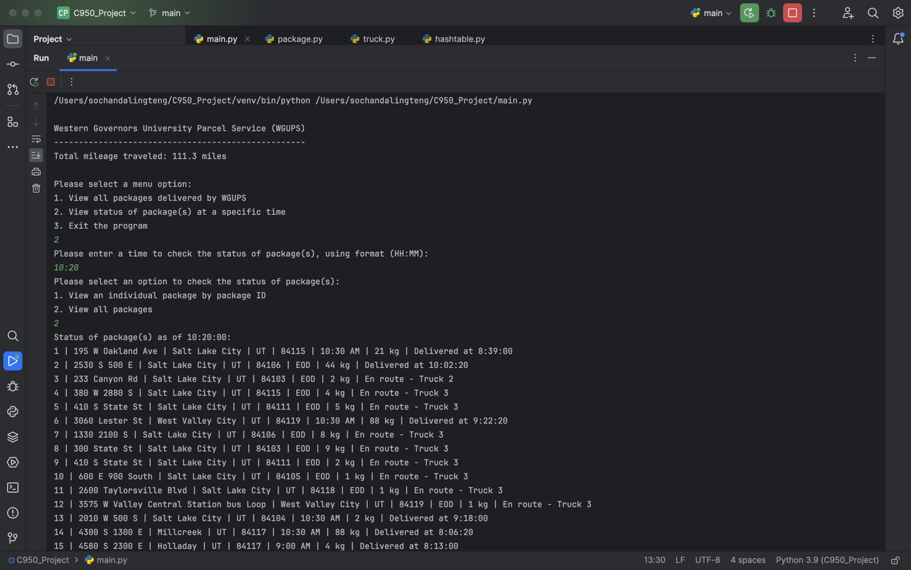

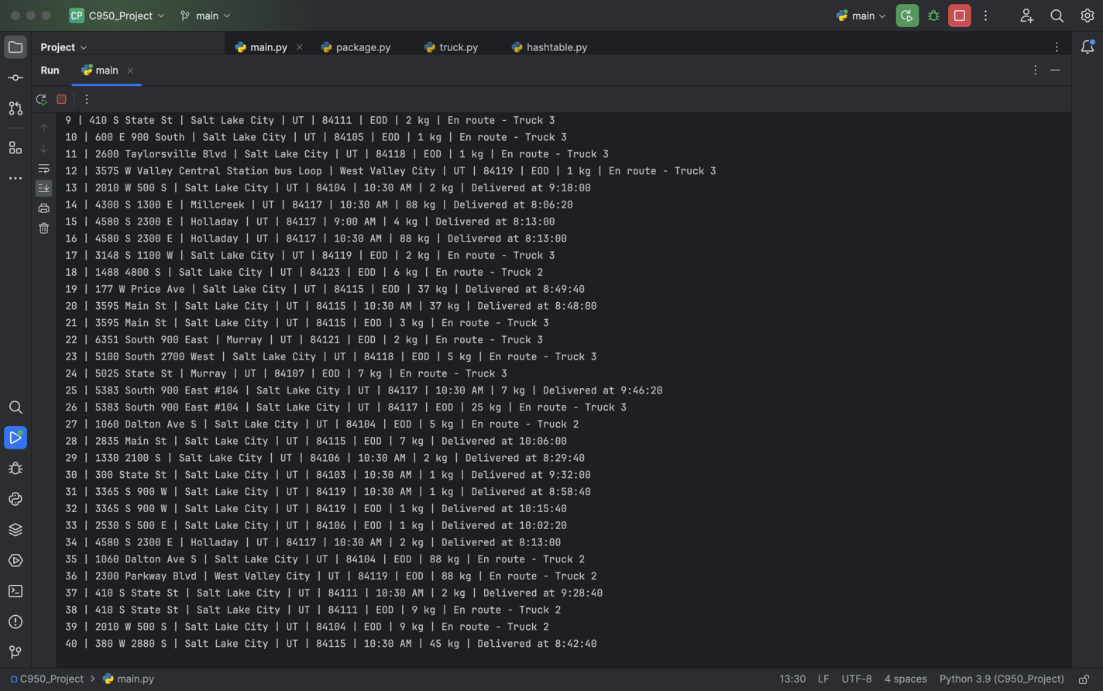

# D3. Third Status Check

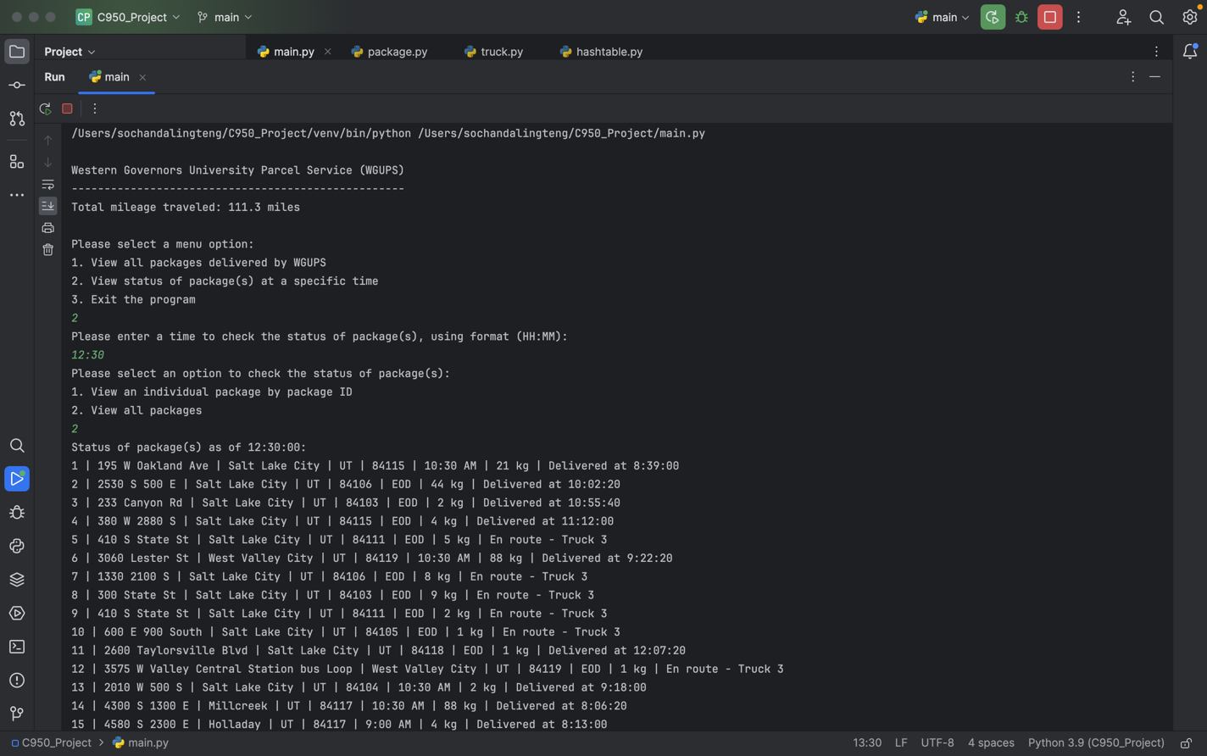

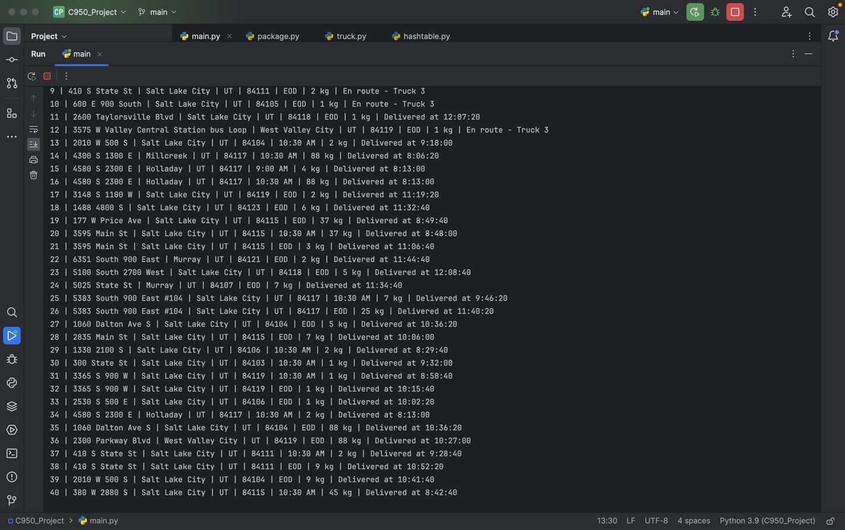

# E. Screenshot of Code Execution

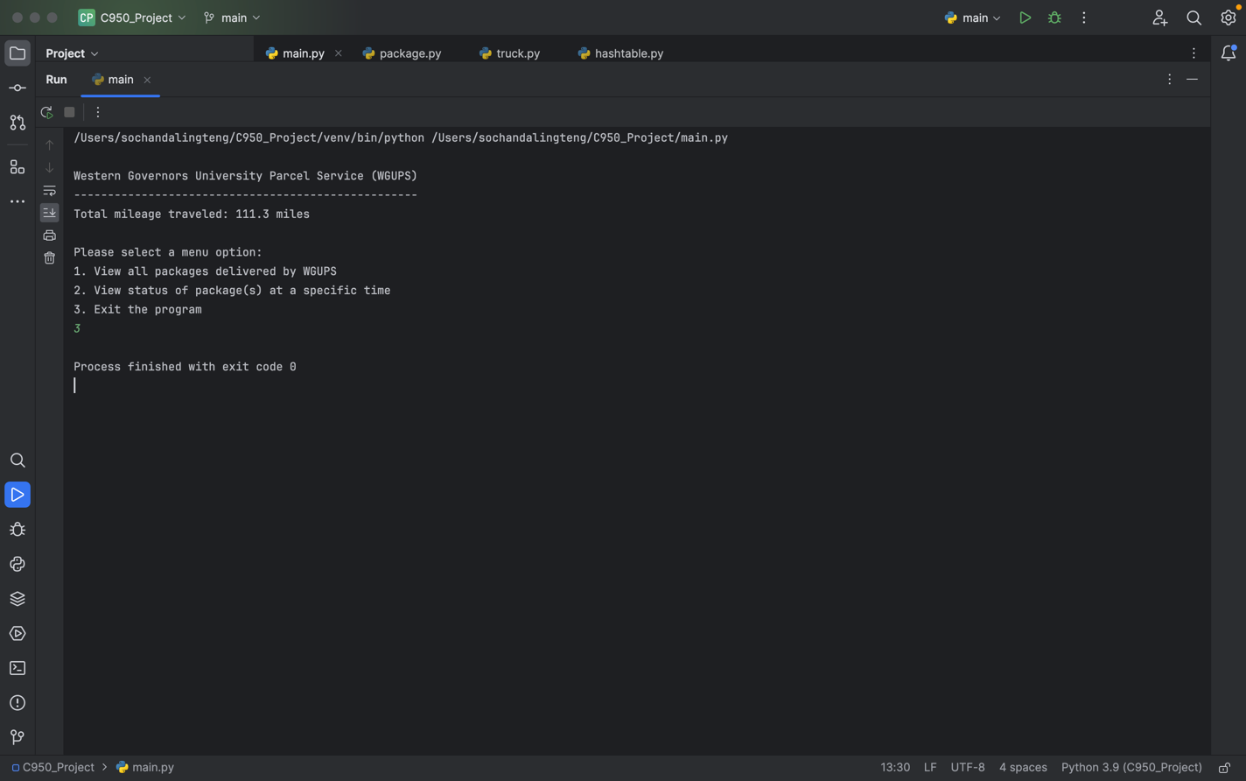

# F1. Strengths of the Chosen Algorithm

The algorithm being used in the solution is the nearest neighbor algorithm. The strengths of this algorithm are:

* It is simple and easy to implement.
* It fits in multi-class cases very well.
* It can handle non-linear data very well without any assumptions about data (Joby, 2023).

# F2. Verification of Algorithm

Nearest neighbor algorithm being used in the solution meets all requirements. All packages are delivered on time within each package’s requirements and a total distance under 140 miles. The algorithm can handle the package that has special notes very well such as package delayed, specific truck required and address changed at a specific time. For the package delayed until 9:05 am, it makes sure that the truck won’t leave the hub until it loads with the package at 9:05 am. It also handles packages that need to be delivered together and makes sure that all packages are delivered by the end of the day.

# F3. Other Possible Algorithms

Other algorithms that are different from the algorithm implemented in the solution and would meet all requirements are “Dijkstra’s Algorithm” and “Bellman-Ford Algorithm”.

# F3a. Algorithm Differences

Dijkstra’s algorithm could be implemented to meet all requirements in the scenario. It is used for graph data structure to find the shortest path from one node to every other single node within the same graph until all nodes are visited. Similarly, Bellman-Ford algorithm could also be implemented in the solution to find the shortest path between the starting node and all other nodes in the graph. It is more versatile than Dijkstra’s algorithm as it can handle graphs with negative edges by terminating on a negative cycle, meaning there is no shortest path.

Both algorithms are different from my solution as nearest neighbor algorithm is best used for classes while the other two algorithms are used for graphs. Plus, nearest neighbor algorithm is used to find the shortest path from one node to the other node depending on the distance of the closest nodes it could reach as the nearest neighbor while the other two algorithms find the shortest path by directly choosing the closest node to the current point. For nearest neighbor algorithm, it stores a list of items and calculates the distance to each of the stored items, then it returns the closest one. For Dijkstra’s algorithm or Bellman-Ford algorithm, it takes input of a graph, a starting node and a target node, then returns the shortest path directly.

# G. Different Approach

If I could do this project differently, I would incorporate two changes for future enhancements and improvements. First, without manually loading packages to each truck, I would create a function to load each truck based on the package’s criteria. To start with, I will initialize each truck as an empty list and create conditions to append each list by prioritizing packages that have special notes and earliest delivery deadlines. Then, for packages with no special note and delivery deadline by EOD, if the package is not on any truck yet, I would load it to the truck that has packages to the same address, or else I would load it on the truck that has fewer packages. Second, I would incorporate “OSMnx Python Package” into this project. To start with, I will install the package and use its built-in modules and functions to build my program to meet all requirements in the scenario. OSMnx also interacts with OpenStreetMap API which allows more features such as calculating shortest paths, modeling street networks and other infrastructures, visualizing points of interest data and so on (Boeing, 2023).

# H. Verification of Data Structure

Hash table is the data structure being used in the solution that meets all requirements. It stores the package data accurately as key-value pairs with the key being the unique package ID and the value being other data components such as address, city, state, zipcode, deadline, weight and special notes. The hash table allows for quick access and retrieves package data easily by using the key (package ID) to get the corresponding package information since all data components are associated together with the matching key.

# H1. Other Data Structures

Other data structures that are different from the data structure used in the solution and would meet all requirements are “Set” and “Dictionary”.

# H1a. Data Structure Differences

Set is a data structure that could be used in the solution to store package data as an unordered collection of data which is iterable and mutable. Elements in the set cannot be duplicated and can store a mixture of data types (GeeksforGeeks, 2023). Set operations include union, intersection and difference. Packages in the set can be stored as a dynamic set or a static set which is different from the hash table which stores packages as objects and can be accessed by using the key to return its corresponding value.

Dictionary is a data structure that could also be used in the solution to store package data as a collection of key-value pairs. Each key in the dictionary is associated with its value and must be unique and immutable while its value can be duplicated and be any data type (GeeksforGeeks, 2023). Dictionary operations include get, update and pop using its built-in functions. Elements in the dictionary can be accessed by using keys to map to values directly in the dictionary while the hash table uses hash functions to map keys to its bucket that stores one or more values. Furthermore, dictionaries can be nested into multiple levels of key-value pairs to allow for more hierarchical data structures (GeeksforGeeks, 2023).

# I. Sources

Boeing, G. (2023). *OSMnx 1.7.1 documentation.* *Getting Started*. Retrieved November 28, 2023 from <https://osmnx.readthedocs.io/en/stable/getting-started.html>

GeeksforGeeks. (2023). *Python Dictionary.* Retrieved November 28, 2023 from <https://www.geeksforgeeks.org/python-dictionary/?ref=lbp>

GeeksforGeeks. (2023). *Sets in Python.* Retrieved November 28, 2023 from <https://www.geeksforgeeks.org/sets-in-python/>

Joby, A. (2023). *K Nearest Neighbor or KNN Algorithm And It's Essence in ML.* Retrieved November 22, 2023, from <https://learn.g2.com/k-nearest-neighbor>